From Raids To Ragnarok: A Reexamination of Viking Culture

The Tapestry of Life, Death, and the Afterlife

By Samuel Peter

RELG 57.06: History of Heave, Spring 2024



Valknaut(most likely a symbol of Odin)

Source: Chris Anne, Dreambuilder and Brand Catcher

Contents:

**Introduction And Historical Context 3**

**Funerary Rituals 4**

**The Afterlife 6**

1. Valhalla: 7

2. Folkvangr: 8

3. Helheim(Hel): 8

**Influence Of Religious/Afterlife Beliefs 9**

**Conclusion 10**

**Reference Images 12**

**Works Cited 15**

## Introduction And Historical Context

The prevailing modern perception of the Vikings as raiders and pillagers often overshadows the broader historical significance of the Viking Age, which spanned from 793 to 1066 AD. This era witnessed a notable surge in Norse expansion, as Vikings embarked on extensive voyages. Their advanced longships, complemented by their adept knowledge of astronomy and mathematics, revolutionized maritime travel and significantly contributed to exploration and conquest (Magazine). Beyond their martial reputation, the Vikings were astute traders and skilled artisans, establishing trade networks across Europe and leaving a lasting impact on the economies and cultures of the regions they encountered. Their influence extended to North America (Vinland), Russia, Constantinople, and the Mediterranean, highlighting their significant reach across vast expanses.

The maritime capabilities of the Vikings facilitated the establishment of trade routes that connected Scandinavia with the rest of Europe, Asia, and the Middle East, contributing to cultural exchange and the transfer of knowledge, technology, and ideas. Moreover, the Viking Age catalyzed political transformations within Scandinavia. The Vikings’ Althing, the world’s first parliamentary government, continues to serve as the foundation for governance in many countries today (Magazine). The rise of a warrior aristocracy and the influence of Viking culture extended beyond Scandinavia, influencing European politics through alliances, marriages, and conflicts.

The legacy of the Vikings transcended their time, leaving a lasting imprint on Scandinavian culture. Their art, intricate legal systems, and cultural influence endured for generations. The Old Norse language has significantly influenced the development of numerous European languages, while Norse literature and mythology continued to shape Scandinavian and global culture. Furthermore, evidence from DNA analysis continues to provide insights into the enduring impact of Norse explorers on the world, and the prevalence of Viking place names across Europe serves as a testament to their widespread diaspora. In conclusion, the Viking Age was not solely characterized by warfare; it represented a dynamic era of exploration, trade, and state formation that profoundly shaped the trajectory of Scandinavian history and left an indelible mark on global civilization.

In delving into the beliefs in the afterlife and the funerary traditions/customs of the Vikings, it becomes more evident that their society was notably intricate and advanced, starkly contrasting the prevailing stereotype of raiders and plunderers. This scholarly inquiry offers a deeper comprehension of Viking civilization, transcending oversimplified perceptions and highlighting the complexity and sophistication of their beliefs and customs. By explicitly examining Viking afterlife beliefs and funerary practices, a more nuanced understanding of their society is offered, emphasizing the multifaceted nature of the Viking Age and the imperative to acknowledge the Vikings as a sophisticated and influential society that made substantial contributions to global civilization. Examining Viking funerary practices and accompanying belief systems will shed light on a society far richer than the stereotype suggests, revealing a people preoccupied with questions of existence, the divine, and the enduring legacy they wished to leave behind.

## Funerary Rituals

The funerary customs of the Vikings were remarkably diverse, reflecting the profound veneration that the Norse society held for the departed. Originating from pagan traditions and beliefs, these rituals encompassed a wide spectrum of practices, ranging from ceremonial burial at sea in grand ships to the solemnity of cremation on pyres. The primary objective of these rites was to guarantee the safe passage of the deceased to the afterlife, frequently involving the inclusion of burial offerings and animal or human sacrifices. Viking funerary rituals served a threefold purpose: preparing the departed for the afterlife, commemorating their life's accomplishments, and ensuring a seamless transition to the next realm (Vaia). These rituals reveal a society deeply committed to honoring their deceased and preoccupied with the spiritual dimensions of existence and mortality, a complexity that far surpasses the portrayal of mere ruthless savagery.

The preparation of the deceased for their journey to the afterlife entailed a meticulous process involving washing and grooming, signifying the utmost respect for the departed. The significance of cleanliness in this funerary ritual cannot be understated, as it symbolizes the reverence accorded to the deceased. Notably, the funeral rite included the trimming of fingernails, as documented in the Prose Edda by Snorri Sturluson, exemplifying the scrupulous measures taken to impede the completion of the construction of Naglfar, the mythical ship destined to ferry the army of jötnar from Hel during Ragnarök (Wikimedia Foundation, Inc.). Furthermore, the interment attire of the deceased often comprised their finest garments or specific attire designated for burial, frequently accompanied by weapons, armor, or other items of significance reflective of their life and societal standing.

The funerary practices of the Vikings encompassed both cremation and burial rituals. Cremation, often conducted on a funeral pyre, was prevalent among the early pagan Vikings, signifying their belief that the smoke from the fire would aid the departed in their journey to the afterlife (Morgan). Following cremation, the remains of the deceased were interred through burial. The burial practices exhibited significant variation, ranging from shallow graves to burial mounds capable of accommodating multiple bodies, as well as groupings of mounds known as "grave fields," which served purposes akin to modern cemeteries. The gradual adoption of Christianity led to a transition towards burials, accompanied by a decline in the inclusion of grave goods in the funerary rites (Open AI). The use of boats held a profound significance in Viking funerary customs, a representation of the safe journey into the afterlife, symbolically mirroring the mode of transportation employed by the Vikings during their earthly existence (Vaia). Certain burial mounds were deliberately shaped to mimic the form of ships, with stones meticulously arranged to delineate the contours of the vessel. In the case of esteemed individuals within Norse society, the funerary practices elevated to the interment of the deceased alongside their actual boats. It is worth noting that the prevalent notion of sending funeral boats out to sea was infrequent, primarily due to the exorbitant costs associated with the construction of these revered longships (Martin). Consequently, this method of cremation was predominantly reserved for the most privileged members of Viking society.

Grave goods, comprising weaponry, jewelry, and tools, were interred with the deceased to ensure their provision in the afterlife, as well as to symbolize the individual's life and societal standing (Martin). Additionally, cherished animals and enslaved individuals were included in the grave goods, intended to accompany the departed and fulfill their needs in the afterlife. The excavation of the "Oseberg ship," an exceptionally well-preserved Viking relic dating back to approximately 834 A.D., provides invaluable insights into the intricate funerary customs of the Vikings. Discovered within a burial mound in Norway, the Oseberg ship represented not only a vessel but also an opulent burial chamber containing the remarkably well-preserved remains of two prominent women. Accompanying them were an array of grave goods, including intricately adorned sleighs, tapestries, wooden carvings, and everyday items such as cooking utensils and textiles. This abundance of items underscores the significance accorded to honoring these women in the afterlife and strongly indicates their esteemed social status. The Oseberg burial challenges the conventional perception of Viking women being solely relegated to domestic roles. Particularly, women of elevated social standing likely occupied a broader spectrum of responsibilities. They may have been engaged in estate administration, partaken in religious rites, and potentially held positions of authority.

Following the burial, a ceremonial funeral feast, known as "sjaund," was convened to commemorate the departed and provide solace to the bereaved family (Martin). The sjaund observances encompassed a wide range of rituals, including elaborate banquets in honor of the deceased and solemn offerings intended to facilitate the deceased’s passage to the afterlife. These commemorative gatherings featured extended periods of feasting, libations, musical performances, vocal recitations, transcendental experiences, as well as the observance of sacrifices involving both humans and animals. The funeral ale, also referred to as sjaund, served as a means of socially acknowledging the occurrence of death, and it was only after partaking in the funeral ale that the rightful beneficiaries could lay claim to their inheritance (Wikimedia Foundation, Inc.). In instances where the deceased was a widow or the head of the household, the designated heir would ascend to the prominent seat, symbolizing the transfer of authority and responsibility.

These findings regarding the funeral customs of the Vikings yield valuable insights into their intricate beliefs about the afterlife, social structures, and the profound importance of honor and legacy within their society. Through an exploration of the diverse array of Viking funerary practices, we are able to discern a civilization that far exceeds the oversimplified portrayal of ruthless marauders. The meticulous preparation of the deceased, the array of burial methods, and the inclusion of grave goods tailored to each individual convey a deep reverence for the departed and the complexity of their belief systems. The emphasis on cleanliness and the connections to Norse mythology, such as the trimming of fingernails to impede the construction of Naglfar, showcase a deep connection with the spiritual realm. In conclusion, Viking funerary rituals provide insight into a society that was profoundly concerned with the afterlife. These intricate traditions present a compelling counterbalance to the stereotypical image of Vikings, revealing a people rich in culture, considerate in their approach to death, and highly astute in their understanding of the world around them.

## The Afterlife

The intricate funerary practices of the Vikings not only demonstrated a profound reverence for their deceased members but also underscored a deep-seated belief in the journey that lay beyond the grave. According to Viking cosmology, the universe comprised nine realms situated on Yggdrasil, the cosmic ash tree. These realms included Asgard (the abode of the gods), Alfheim (the realm of the light elves presided over by the goddess Freya), Nidavellir (the domain of the Dwarfs, skilled smiths and craftsmen working in mines and forges), Midgard (Earth), Jotunheimr (the homeland of the Jotnar or giants, where an eternal winter prevails), Vanaheim (the home of the Vanir, deities associated with fertility, wisdom, and prophecy), Niflheim (the realm of primordial ice), Muspelheim (the realm of fire ruled by Surtr, a central antagonist during Ragnarok), and Hel (an underworld where life continues) (Milligan).

What awaited these warriors and nobles after their earthly journeys concluded? In Norse mythology, the afterlife is depicted as a complex tapestry of beliefs and narratives, encompassing various realms, deities, and traditions that reflect the values and perspectives of the culture. This brief overview provides insight into the ultimate destination for souls in the journey of the afterlife:

### Valhalla:

The hall of Valhalla, situated in Asgard and overseen by Odin, the King of the Aesir clan and father of all gods, is a majestic abode where courageous warriors, known as Einherjar, who perish in battle, prepare for Ragnarok. They engage in daily combat and partake in nightly feasting on a magical boar named Saehrimnir, which is regenerated every morning, symbolizing honor and heroism. Entry into Valhalla is exclusive and reserved for those who die a glorious death in battle. Valkyries, a group of maidens who serve Odin and determine the outcome of battles, select and accompany the worthy to Valhalla (Tetzner).

Described in Old Norse poems as immense and majestic, Valhalla's rafters are constructed of spears, its roof is thatched with shields, and coats of mail are draped over the benches (Tetzner). It serves not only as a feasting hall but also as a training ground for Ragnarok. The Einherjar engage in epic battles within the courtyard known as Valholl, honing their skills and preparing for the final war. Despite the daily combat, they magically heal by nightfall, ready to fight again the next day (Tetzner).

Valhalla's purpose is intrinsically tied to Ragnarok, the twilight of the gods. When this day arrives, the Einherjar will march out of Valhalla's 540 doors, led by Odin, to engage in a final, epic battle against the forces of chaos. The daily training and feasting within Valhalla prepare them for this ultimate war. Valhalla transcends being a mere place of brute force. The constant feasting underscores the significance of communion and camaraderie among warriors. It is a complex paradise designed to create the ultimate army for the gods.

### Folkvangr:

In Norse Mythology, Valhalla is widely recognized as the primary afterlife destination for warriors. However, Folkvangr presents an intriguing alternative. Unlike the martial ambiance associated with Valhalla, Folkvangr is depicted as a serene meadow or field. Some interpretations posit that Folkvangr may not be a distinct realm but instead a specific area within Valhalla under the dominion of Freyja, the goddess of fate, love, beauty, gold, war, and fertility. This tranquil setting aligns with Freyja's associations with love, beauty, and fertility, while still acknowledging the aspect of warfare. Folkvangr is considered a resting place for warriors chosen by different criteria than those admitted to Valhalla. Additionally, Folkvangr is believed to be the afterlife destination for souls who have perished from other causes (Apel). It is thought that Freyja's hall, Sessrumnir, resided in Folkvangr. Traditionally depicted as a grand palace, there is speculation that Sessrumnir might have been a ship positioned in a meadow, a representation that likely held deep significance for the Norse people, who frequently constructed burial mounds resembling ships (Apel).

The criteria for selection for Folkvangr are somewhat ambiguous (Open AI). Some sources claim that Freyja chooses half of all fallen warriors, disregarding Odin's claim. Others suggest that her selection is based on unspecified criteria. Unlike Valhalla, there are limited accounts of life within Folkvangr. While daily battles are not mentioned, warriors may still refine their skills in anticipation of Ragnarök. Despite the scarcity of detailed accounts, Folkvangr holds a significant place in Norse mythology, underscoring the prominence of Freyja as a formidable goddess and presenting an alternative vision of the afterlife for warriors. Folkvangr is portrayed as a realm where beauty and war coexist, chosen by a goddess who embodies both love and fierce combat.

### Helheim(Hel):

While Valhalla and Folkvangr are revered as the final resting places for warriors chosen for their valor, Helheim offers a contrasting view of the afterlife. Also known simply as Hel, this realm is situated in Niflheim, characterized by its misty darkness and cold (Apel). Ruled by Hel, the daughter of Loki, Helheim serves as the destination for the majority of deceased individuals, in contrast to the selective halls of Valhalla and Folkvangr. Unlike these renowned afterlife destinations, Helheim is neither a place of punishment nor a glorious paradise. Instead, life in Helheim continues much as it did on Earth, devoid of a grand cosmic purpose (Hall). However, Hel’s army of the dead, more accurately characterized as chaotic and destructive, is prophesied to rise from Hel to join the battle against Odin during Ragnarök (Apel).

Despite its lack of glamour compared to the heroic afterlife realms, Helheim holds a pivotal place in Norse mythology, serving as a representation of the fate of the majority of people and offering a counterpoint to the heroic halls of Valhalla and Folkvangr. It serves as a reminder that death is an inherent part of life and that existence in the afterlife can manifest in diverse forms. Hel's location beneath Yggdrasil, the Norse tree of life encompassing all nine worlds, signifies a balance between the realms of the living and the dead. Just as the roots stabilize the tree, death stabilizes life, ensuring the natural order. Hel's positioning reflects the Norse understanding of the cyclical nature of life. Death (Hel) is not a separate, isolated phenomenon but an integral part of the cosmic order, supporting the continuation and regeneration of life (Open AI).

The arrival of Christianity significantly influenced perceptions of Hel and the afterlife by introducing the concept of heaven and hell as eternal rewards and punishments. Consequently, Hel was increasingly viewed through a Christian lens and transformed into a place of eternal suffering for the wicked (Hall). The goddess Hel began to be depicted as a figure associated with evil and suffering, deviating from her more neutral role in Norse mythology (Hall). The Christian notion of a final judgment supplanted the Norse cyclical view of death and rebirth, portraying Hel as a realm of permanent damnation rather than a stage in the cycle of existence. Another key transformation of Hel through Christianity was the creation of Náströnd (Hall). Náströnd, a sub-realm within Helheim, is reserved for the most nefarious souls, including oathbreakers, murderers, and adulterers, who endure eternal torment. Described as a shore covered in venom, Náströnd is inhabited by a monstrous serpent named Nidhogg, perpetually gnawing on the corpses of the damned. The very air is saturated with venom dripping from a roof woven from snakes (Open AI).

## Influence Of Religious/Afterlife Beliefs

The religious beliefs of the Vikings, particularly those of the afterlife, held a significant role in shaping their societal framework. The Viking cosmology encompassed a complex understanding of the afterlife, which profoundly influenced various facets of their culture, behavior, and social organization.

Central to Viking beliefs were the concepts of Valhalla and Hel, representing distinct realms where souls could dwell after death. The belief in Valhalla, in particular, profoundly influenced Viking behavior and social norms. The glorification of martial valor and the reverence of warriors within Viking society was directly associated with the promise of a splendid afterlife in Valhalla, where fallen warriors would partake in feasts and battles alongside gods and heroes (Follow The Vikings). This emphasis on martial prowess not only shaped the cultural landscape of the Vikings but also impacted their daily practices, including their approach to warfare, exploration, and burial customs (Open AI). The elaborate burials of high-status individuals, often accompanied by grave goods such as weapons and jewelry, as well as ship burials, reflected the belief in preparing the deceased for their journey to the afterlife, symbolizing a voyage to the next world (Follow The Vikings). Furthermore, the concept of fate and destiny, governed by the Norns, mythical beings who controlled fate, instilled everyday Viking life with a sense of fatalism and determination. This belief in the influence of one's actions in this world on their status in the afterlife contributed to a culture of adherence to social norms and a pursuit of honor (Open AI).

The eventual conversion of the Vikings to Christianity brought about significant changes to their religious landscape, introducing new moral imperatives and afterlife expectations. The shift from a warrior-oriented afterlife to one focused on salvation and eternal peace had profound implications, gradually transforming societal values and norms. Christian burial practices began to supplant traditional Viking rites, and the new religion's emphasis on mercy and piety began to permeate Viking culture. The legacy of Viking beliefs in Valhalla and the afterlife continued to influence their cultural heritage even as they transitioned to Christianity, leaving a lasting imprint on their societal values and norms. The interplay between religious beliefs, societal structure, and cultural practices underscores the profound impact of Viking cosmology on their civilization and its evolution.

## Conclusion

The study of Viking funerary practices and afterlife beliefs has elucidated a society that is far more intricate and sophisticated than the common portrayal of ruthless raiders. The thorough preparation of the deceased, the diverse burial methods, and the inclusion of carefully selected grave goods all signify a deep-rooted belief in the afterlife. This belief system, far from being a mere coping mechanism for death, had a profound impact on Viking society.

The Viking afterlife, characterized by interconnected realms and diverse destinations, presents a cosmology of interdependence (Viking Style). The fate of the deceased in Valhalla or Folkvangr had an impact on the gods' readiness for Ragnarok, just as the actions of the living influenced the afterlife. This concept likely translated into a social value system that emphasized community and cooperation. Each individual played a crucial role in maintaining cosmic balance, and their contributions were highly valued. Similarly, the cyclical nature of life and death, with new life emerging after Ragnarok, mirrored the Norse understanding of the natural world. Death on Earth was not an isolated event but a necessary part of a grander cycle.

These beliefs also cultivated a culture that embraced honor and respect. The elaborate burials and funerary practices reflected the social standing and accomplishments of the deceased. The idea of Valhalla, reserved for courageous warriors, further underscored the importance of honor. However, Viking society was not solely focused on warriors. Respect for the natural world, evident in their pantheon of gods, fostered a sense of harmony with nature (Viking Style). Furthermore, while patriarchal, Norse society offered greater gender equality compared to other civilizations of the time, with women having property rights and influence in their communities.

This paper underscores the significance of transcending stereotypes. By delving into Viking beliefs about death and the afterlife, we gain a deeper understanding of their social values, motivations, and worldviews. Future research could delve into regional variations in Viking funerary practices, the detailed transition of traditional/pagan Norse beliefs into more Christian beliefs, or explore the potential influence of these beliefs on artistic expressions or storytelling traditions. The intricate tapestry of Viking beliefs offers a fertile ground for further exploration, reminding us that even the most seemingly brutal societies held complex and nuanced views on life, death, and the cosmos.

## Reference Images

Figure 1: Map showing the breadth of Viking voyages. Source: Viking Age, Wikipedia

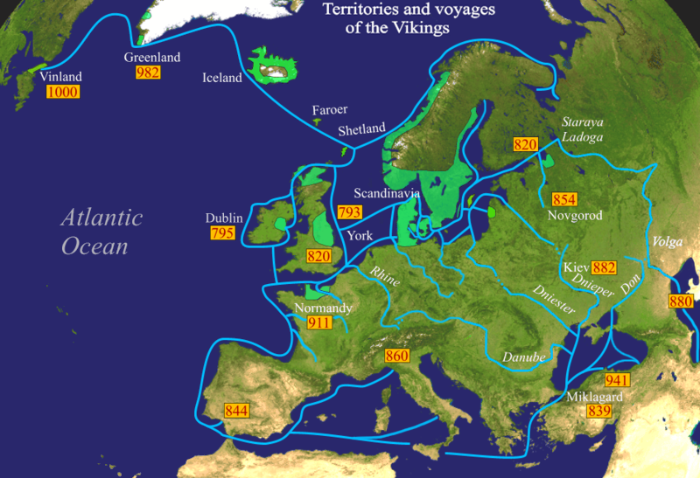

Figure 2: Oseberg Ship in the Museum of Viking Age in Oslo. Source: Oseberg Ship, Encylopedia Britannica

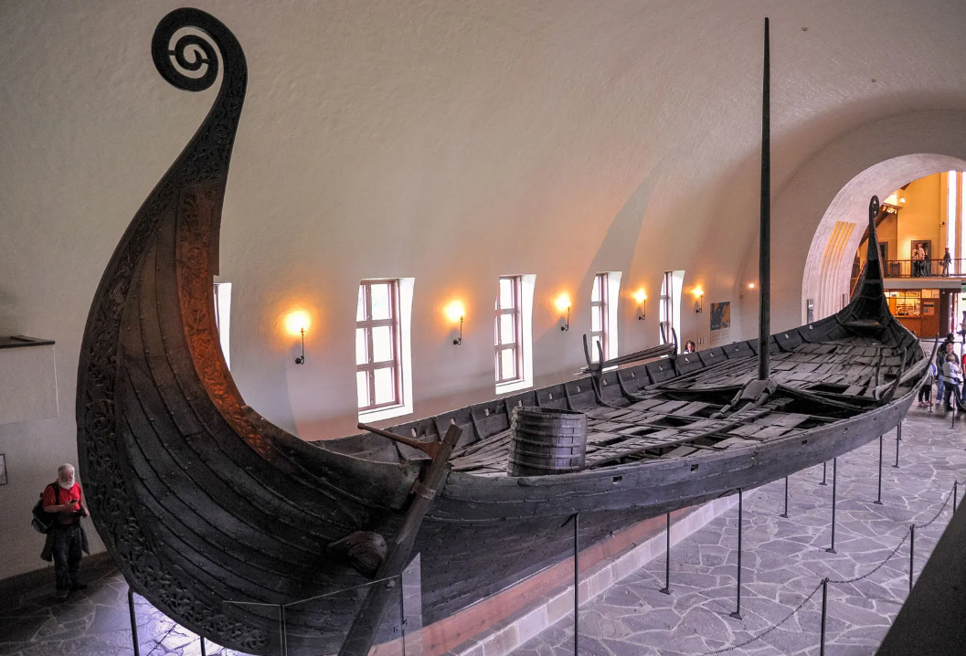

Figure 3: Viking burial site north of Alborg Denmark. Source: Ted Speigel, Getty Images

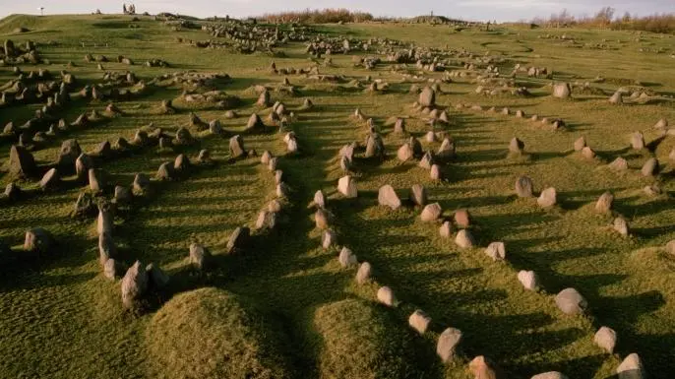

Figure 4: An artist’s impression of Yggdrasil and the nine realms. Source: Marius, Vikingr

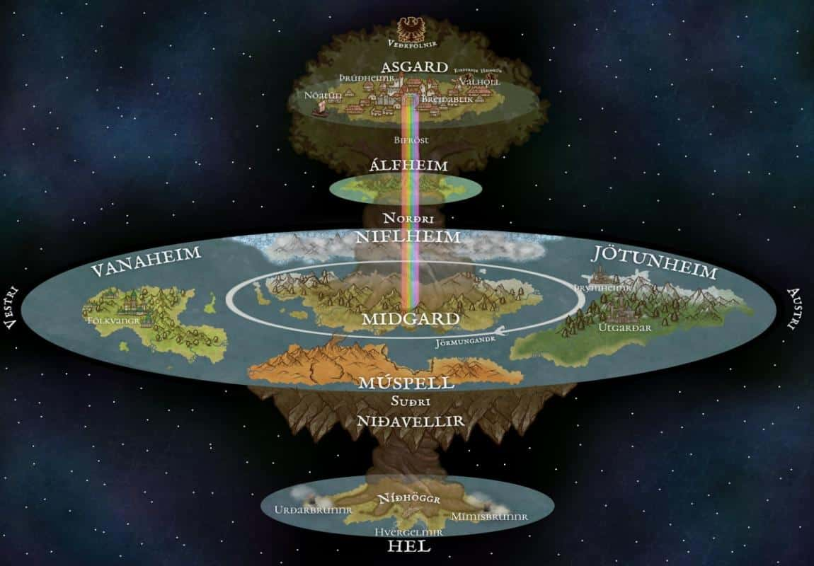

Figure 5: Representation of a Viking boat funeral with grave goods. Source: Viking funeral, Art.com

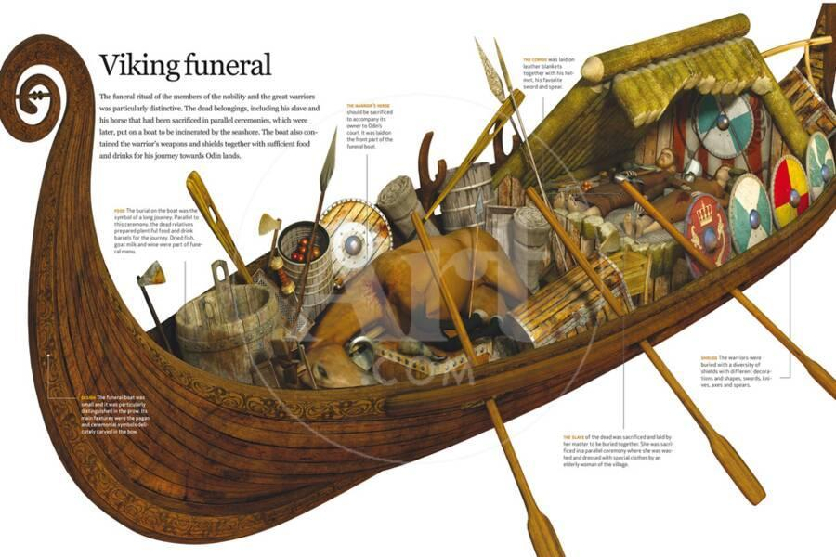

## Works Cited

Apel, Thomas. “Fólkvangr.” Mythopedia, 7 December 2022, https://mythopedia.com/topics/folkvangr. Accessed 26 May 2024.

Apel, Thomas. “Hel (Realm).” Mythopedia, 29 December 2022, https://mythopedia.com/topics/hel-realm. Accessed 26 May 2024.

Follow The Vikings. “Viking Age Religion and Beliefs.” Council of Europe, https://www.followthevikings.com/discover/culture/religion-and-belief/viking-age-religion-and-belief. Accessed 26 May 2024.

Hall, Angela. “Death and the Afterlife.” Norse Mythology for Smart People, https://norse-mythology.org/concepts/death-and-the-afterlife/. Accessed 26 May 2024.

Hall, Angela. “Hel (The Underworld).” Norse Mythology for Smart People, https://norse-mythology.org/cosmology/the-nine-worlds/helheim/. Accessed 26 May 2024.

Magazine. “The Historical Importance of the Vikings | Berjaya Hotels.” Iceland Hotel Collection by Berjaya, 12 November 2014, https://www.icelandhotelcollectionbyberjaya.com/magazine/blog/importance-of-the-vikings-mag. Accessed 25 May 2024.

Martin, Anthony. “Viking Funeral Rituals.” Choice Mutual, 27 September 2023, https://choicemutual.com/blog/viking-funeral-rituals/. Accessed 27 May 2024.

Milligan, Mark. “Yggdrasil and the 9 Norse Worlds.” Heritage Daily, 2 August 2018, https://www.heritagedaily.com/2018/08/yggdrasil-and-the-9-norse-worlds/121244. Accessed 27 May 2024.

Morgan, Thaddeus. “How Did The Vikings Honor Their Dead?” HISTORY, 20 July 2017, https://www.history.com/news/how-did-the-vikings-honor-their-dead. Accessed 27 May 2024.

Open AI. “Viking Age Overview Chat.” Open AI, 25 May 2024, https://chatgpt.com/share/991322f6-7fc9-4f4b-a6bf-1d133c0d770d. Accessed 25 May 2024.

Tetzner, Noah. “Valhalla: How Viking Belief in a Glorious Afterlife Empowered Warriors.” 3 March 2021, https://www.history.com/news/viking-valhalla-valkyrie-afterlife. Accessed 26 May 2024.

Vaia. “Viking Funeral Rites: Traditions, Ceremonies.” Vaia, https://www.vaia.com/en-us/explanations/history/viking-history/viking-funeral-rites/. Accessed 27 May 2024.

Viking Style. “What Were The Core Vikings Values?” Viking Style, 7 July 2023, https://viking.style/what-were-the-core-vikings-values/. Accessed 27 May 2024.

Wikimedia Foundation, Inc. “Norse funeral.” *Wikipedia*, Wikimedia Foundation, Inc., https://en.wikipedia.org/wiki/Norse_funeral. Accessed 27 May 2024.

Wikimedia Foundation, Inc. “Viking Age.” *Wikipedia*, Wikimedia Foundation, Inc., https://en.wikipedia.org/wiki/Viking_Age. Accessed 25 May 2024.